**Government Arts and Science College**

**Kanyakumari – 629 401**

**FACULTY PROFILE**

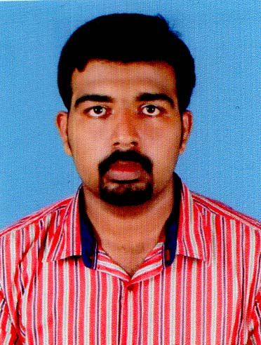

Photo

**Department: Mathematics**

1. **Name : Dr. DIALIN J. DEV**
2. **Father’s Name : Rev. D. Justin Devadhason**
3. **Designation : Assistant Professor**
4. **Age and Date of Birth : 34 and 21-08-1988**
5. **Gender : Male**
6. **Address for Communication: 2/106, Dev Cottage**

**Udaiyarvilai**

**Kannanoor**

**Kanniyakumari District -629158**

**Phone No : 9489404050**

**Email – id : dialinjdev@yahoo.com**

1. **Educational Qualification :**

|  |  |  |  |
| --- | --- | --- | --- |
| **S.No.** | **Course** | **University/College** | **Year of Passing** |
| 1 | B.A., | Scott Christian College, Nagercoil. | 2006-2009 |
| 2 | M.A., | Madras Christian College, Chennai. | 2009-2011 |
| 3 | M.Phil., | Scott Christian College, Nagercoil. | 2011-2012 |
| 4 | Ph.D., | Manonmaniam Sundaranar University, Tirunelveli. | 2013-2016 |

1. **Area of Specialization: American Drama and Indian Literature**

**9. Experience:**

|  |  |  |  |  |
| --- | --- | --- | --- | --- |
| **S.No.** | **Name of Organisation** | **From** | **To** | **Year of Experience** |
| 1. | Lekshmipuram College of Arts and Science, Neyyoor | 07-08-2013 | 22-06-2018 | 5 years |
| 2. |  |  |  |  |
| 3. |  |  |  |  |
| 4. |  |  |  |  |

**10. Publications:**

|  |  |  |  |  |
| --- | --- | --- | --- | --- |
| **S.No.** | **Title** | **Name of the Journal** | **ISSN / ISBN** | **Year** |
| **1** | Self – Actualization through Relationship: A reading of Naomi Wallace’s *And I and Silence* | English Language and Literature | ISBN 9788179663899 | 2014 |
| **2** | Testaments of Survival: A reading of Naomi Wallace’s play “The Trestle at Pope Lick Creek | LPC Bulletin on Research | ISSN 22493417 | 2016 |
| **3** | The Imminence of the concept of Wellbeing portrayed through the Realism in Naomi Wallace’s The *Trestle at Pope Lick Creek* | ROOTS | ISSN 23498684 | 2017 |

1. **Paper Presented in Conferences/ Seminar :**

|  |  |  |  |
| --- | --- | --- | --- |
| **S. No.** | **Title** | **Institution** | **Date & Year** |
| 1 | Self – Actualization through Relationship: A reading of Naomi Wallace’s *And I and Silence* | Rani Anna Government College for Women | 14-03-2014 |
|  |  |  |  |
|  |  |  |  |
|  |  |  |  |

1. **Seminar / Conference / workshop / Attended:**

|  |  |  |
| --- | --- | --- |
| **S.No.** | **Institution** | **Date & Year** |
| 1 | **Scott Christian College, Nagercoil** | 03-03-2012 |
| 2 | **Scott Christian College, Nagercoil** | 29-08-2011 |
| 3 | Scott Christian College, Nagercoil | 07-02-2012 |
| 4 | Holy Cross College, Nagercoil | 17-02-2012 |
| 5 | Scott Christian College, Nagercoil | 17-07-2014 |
| 6 | St. Teresa Arts and Science College for Women, Mangakakuntu | 12-02-2020 |
| 7 | Lekshmipuram College of Arts and Science, Neyyoor | 22,23-02-2018 |
| 8 | Lekshmipuram College of Arts and Science, Neyyoor | 25-02-2016 |
| 9 | Lekshmipuram College of Arts and Science, Neyyoor | 18-02-2016 |
| 10 | Lekshmipuram College of Arts and Science, Neyyoor | 19-02-2016 |
| 11 | Lekshmipuram College of Arts and Science, Neyyoor | 27-03-2015 |
| 12 | Lekshmipuram College of Arts and Science, Neyyoor | 18-02-2015 |
| 13 | Lekshmipuram College of Arts and Science, Neyyoor | 10-01-2004 |
| 14 | Lekshmipuram College of Arts and Science, Neyyoor | 26-02-2014 |
| 15 | St. Jerome’s College ofArts and Science, Nagercoil | 22-07-2016 |
| 16 | Arasu Engineering College, Kumbakonam | 22-02-2022 |
| 17 | Arasu Engineering College, Kumbakonam | 03-02-2022 |

1. **Details of Research Projects :**

|  |  |  |  |
| --- | --- | --- | --- |
| Title | Sponsoring Agency | Amount | Responsibility |
|  |  |  |  |
|  |  |  |  |

### Ph.D Guidance/Supervisorship

|  |  |  |  |
| --- | --- | --- | --- |
| Name of scholar | Course | Area of research | Status |
|  |  |  |  |
|  |  |  |  |

### Seminar/ Conference/ Workshop Organised:

|  |  |  |  |
| --- | --- | --- | --- |
| **S. No.** | **Topic** | **Institution** | **Date** |
|  |  |  |  |
|  |  |  |  |

### Resource Person:

|  |  |  |  |
| --- | --- | --- | --- |
| Sl.No. | Topic | Delivered at | Period |
|  |  |  |  |
|  |  |  |  |

1. **Members in Organization’s :**

### Other Achievements :

### 

### (Signature)